|  |  |
| --- | --- |
| Date | 7 November 2022 |
| Team ID | PNT2022TMID29237 |
| Project name | IOT based safety gadegts for child safety monitoring and notification |

# Project development delivery of sprint 4

* The popularity of smart hand held devices and the development of wearable devices have made crowd sourced sensing networks possible, which can explore the real-time mobility of smart phone users, the sensing capability of wearable devices, and the diverse communication between wearable devices and surrounding smart phones to achieve pervasive sensing results.
* Environmental information and individual status can be less expensively collected and more efficiently distributed for living quality, personal safety, and mobility efficiency such as air quality detection, children status monitoring

# Technical architecture

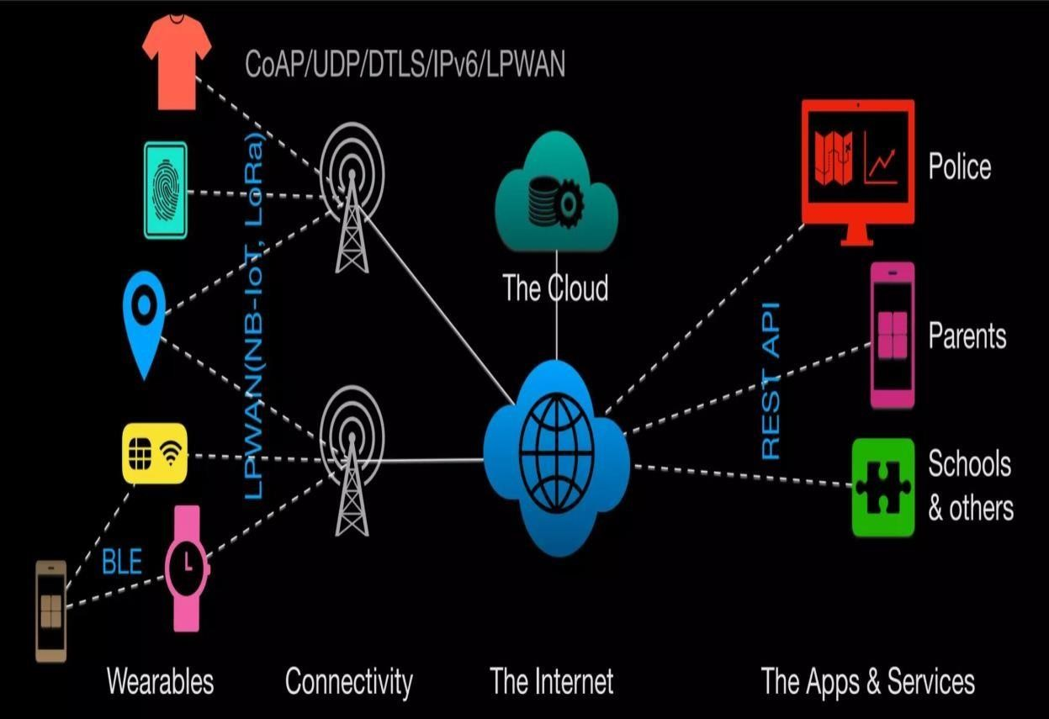

MODULES

* ARDUINO UNO
* LCD
* WSN MODULE
* FLEX SENSOR
* POWER SUPPLY
* BUZZER

**Python code for BUZZER control**

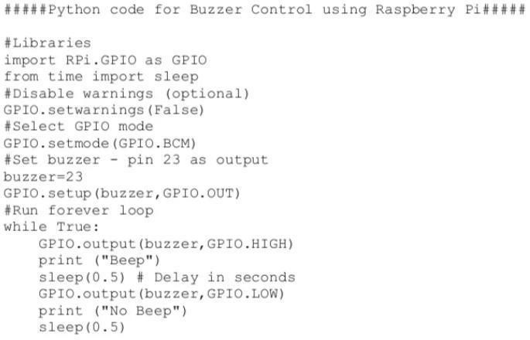

* Buzzer is an auditory signing device, which could be motorized, electromechanical or piezoelectric. Characteristic uses of buzzers and beepers contain alarm devices, timers stroke validation of user input such as a mouse snap or key stroke.
* Buzzer is an combined building of electrical transducers, DC power source, widely used in CPUs, printers, mimeographs, alarms, electronic toys, locomotive microelectronic equipment, phones, timers and other electrical products for sound campaigns.
* Active buzzer 5V Valued power can be straight connected to a incessant sound, this section dedicated sensor growth module and the board in mixture, can whole a simple circuit project, to "plug and play."

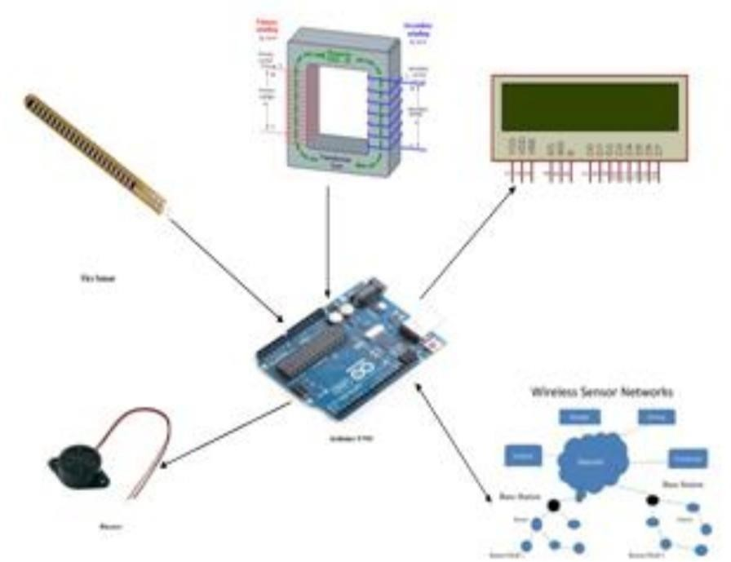

System architecture

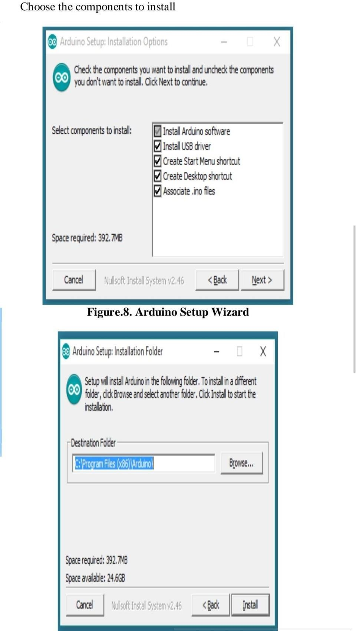

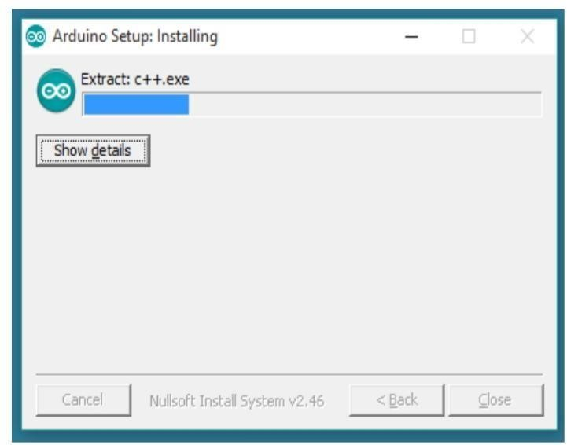

* 1. The child security wearable device is capable of working as a smart device.
  2. It provides parents and child with the alarm buzzer for their child surroundings and also to alert their child and alert parents when the child is moving away from them within the specified distance.
  3. If anyone try to remove the device or apply particular force on the device, then also the alarm will be activated to the parents and the child. And, also the message will be sent to nearest police using the data available in the server.